Brink®

**Epson TM-m30**

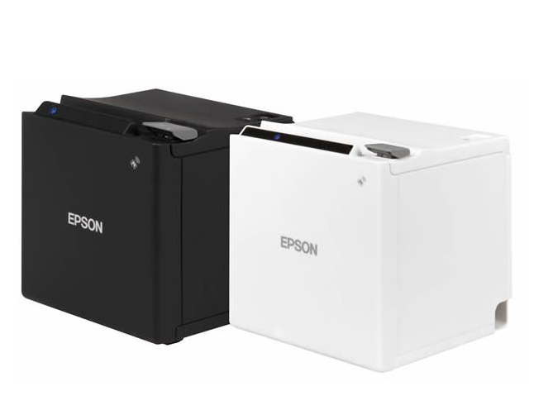

**Publication Details**

**Copyright**

Copyright © ParTech, Inc. 2022. All Rights Reserved. This product and related documentation are protected by copyright and are distributed under licenses restricting their use, copying, distribution, and decompilation. No part of this product or related documentation may be reproduced in any form by any means without prior written authorization of PAR and any requisite licensors.

**Trademarks**

Brink, ParTech, and their respective logos are all trademarks of PAR Technology Corporation.

PAR may have patents, patent applications, trademarks, copyrights, or other intellectual property rights covering subject matter in this document.

Except as expressly provided in any written license agreement from PAR, the furnishing of this document does not give you any license to these patents, trademarks, copyrights, or other intellectual property.

Microsoft® and Window s® are registered trademarks of Microsoft Corporation in the United States and/ or other countries. Other product names may be trademarks or registered trademarks of their respective companies and are hereby acknowledged.

**Disclaimer**

PAR has thoroughly reviewed this document and believes it to be reliable. However, this document is provided for informational purposes only and PAR makes no warranties, either expressed or implied, in this document. Information in this document is subject to change without notice. Risk of use and responsibility for the results of use of this document lie with the user.

**Patents**

The following patents apply to some areas of functionality within the Brink software suite: Pat.

6,384,850; 6,871,325; 6,982,733; 8,146,077; 8,287,340

REPrinter Setup and Configuration Overview

Please carefully follow the device manufacturer provided technical reference guide from <https://files.support.epson.com/pdf/pos/bulk/tm-m30_trg_en_revh.pdf>. This guide contains complete setup instructions of the device and any peripherals such as a cash drawer that can be connected.

***For Brink communication it is recommended to interface type to USB-COM Or Ethernet.***

# Requirements:

Brink POS Register

* Version 4.1.5274 To 5.0.566+

EpsonTM-m30 Utility v1.40

* <https://epson.ca/Support/Point-of-Sale/Thermal-Printers/Epson-TM-m30/s/SPT_C31CE95011>

TM Virtual Port Driver v8.60a. TM Virtual Port Driver is a serial/parallel to USB conversion driver

* <https://epson.ca/Support/Point-of-Sale/Thermal-Printers/Epson-TM-m30/s/SPT_C31CE95011>

# Connect the Printer to the Host Device

Please carefully review the manufacturer technical guide instructions from page 30 found in <https://files.support.epson.com/pdf/pos/bulk/tm-m30_trg_en_revh.pdf>

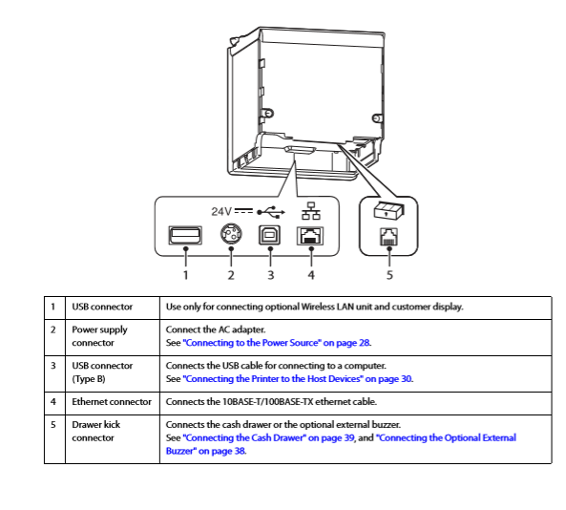

USB-COM interface

For the communication method, the printer must be connected to the host device using USB type B Printer cable. Number 3 on the above diagram.

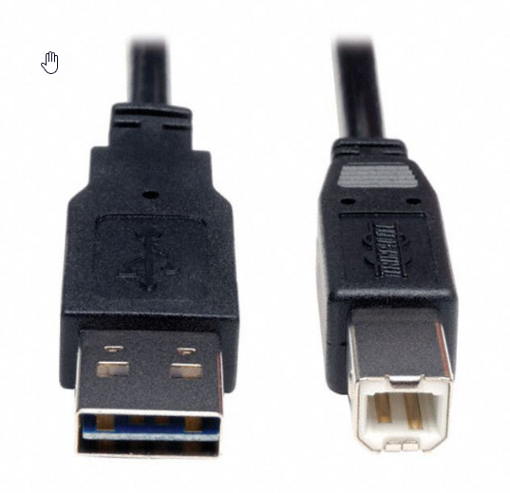

Ethernet Interface

For this communication method, the printer must be connected to the host device using ethernet cable. Number 4 on the diagram in page 5.

1. Install the EpsonTM-m30 Utility v1.40
2. Start the EpsonTM-m30 and select the Interfaces Menu from the left panel Menu

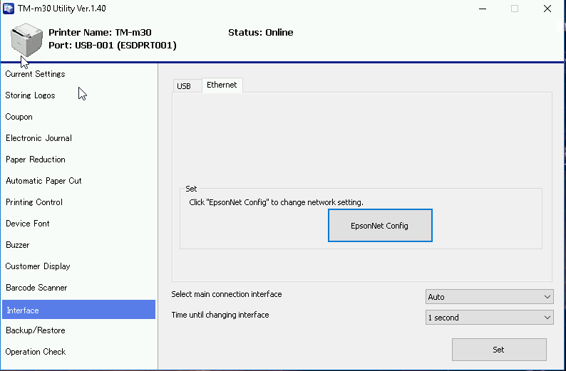

1. Select the Ethernet Tab and click ‘EpsonNet Config’ Button.
   * You can change or configure the device network setting to assign desired IP address. More details on this setting is available on the Manufacturer technical manual.

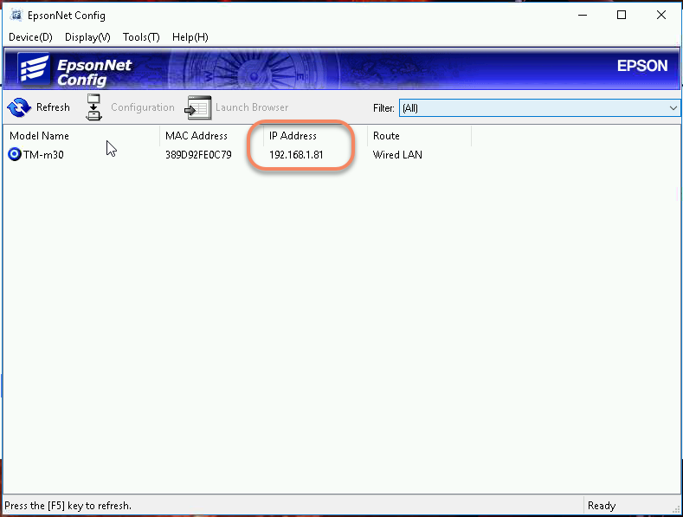

1. Write down the IP Address the Device is set to communicate on. Then Close the Utility.

# Brink Admin Portal Configuration.

1. Log into the customer’s Admin portal

2. Open Settings Editor for the store location

3. Select Printers From the right and Click on ‘Add New Printer’ or you have an existing receipt printer to use, the select the printer.

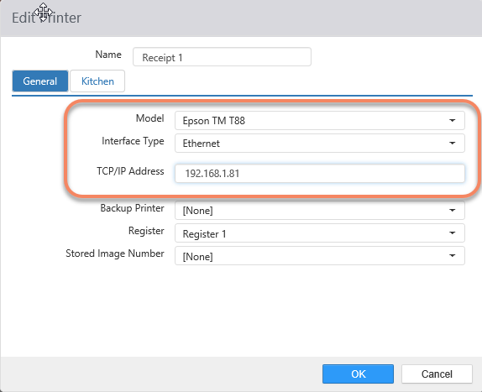

* **Model**: Epson TM T88
* **Interface Type**: Ethernet
* **TCP/IP Address**: 192.168.1.81 (This is only an example IP Address)

4. Select **OK** to Save the changes

5. **Save** and then **Publish** the setting down to the terminal.

**If the client location will be using the printer for Kitchen Chit printing**

Click on Kitchen tab

1. ‘Is Kitchen’ must checked (Enabled)

1. Client location can configure how they would like the Kitchen chit to print by enabling the other option available:

* Print All Items
* Print Only Customized Items
* Chit Type:
  + Single
  + Summary
  + Both

1. Select **OK** to Save the changes
2. **Save** and then **Publish** the setting down to the terminal.

# Assigning Printer to a Register

Applying the printer to run on a register. (i.e. Register 1)

1. Log into the customer’s Admin portal
2. Open Settings Editor for the store location
3. Select Registers
4. From the right and Click on ‘Add New Register’ or you have an existing Register to use, then select that register.
5. When configuring the register ensure the following options have been applied.
6. Ensure to name the Register (i.e. ‘Register 1’)
7. In the Options tab ensure that the following options are configured based on the client location needs.
   1. Lane: Apply the Lane that will be receiving orders printed
   2. Destination: Apply the default destination that will be used for the printer
   3. Section: Apply your Section (if applicable)
   4. Menu: Apply Menu from drop down box (if applicable)
   5. Optional configuration which can be applied if required by the location
      1. Show Mouse Pointer
      2. Auto Open New Order
      3. Expand Keyboard
      4. Play Kitchen Sound
8. Click on the Peripherals Tab
9. Scroll down until you see Default Printer then select the receipt printer desired

1. Once competed Click OK
2. Select **OK** to Save the changes
3. **Save** and then **Publish** the setting down to the terminal.